District Institute of Education & Training,
Bangalore Urban DIET
Rajarajeswari Nagar, Bangalore-18

NAI THALIM
Observation of
NATIONAL SCIENCE DAY

A REPORT

National Science Day
28-02-2019
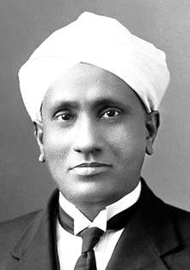
As designated by the Principal, Bangalore Urban DIET, National Science Day competition for the T.T.I.s under the jurisdiction of Bangalore Urban DIET was hosted by St. Teresa’s Women’s T.T.I.
- Date: 28-02-2019
- Time: 10.30 a.m.
- Venue: St. Teresa’s D.El.Ed. Block, Chamarajpet,
Bangalore-18

The judges of the competition were:
- Mr. Guruswamy, R. V. T.T.I.
- Mr. Nagesh, SLN T.T.I.
- Mr. Paramasivam Sacred Heart and St. Teresa T.T.I.s

The progamme began with an invocation followed by welcome speech by Mrs. Mary Kumari. Mr. Guruswamy, R. V. T.T.I. briefed about the significance of NAI TALIM, National Science Day and the competition.

Lots were picked by Mrs. Mary Nirmala, Sacred Heart T.T.I. to decide upon the order of the participants.
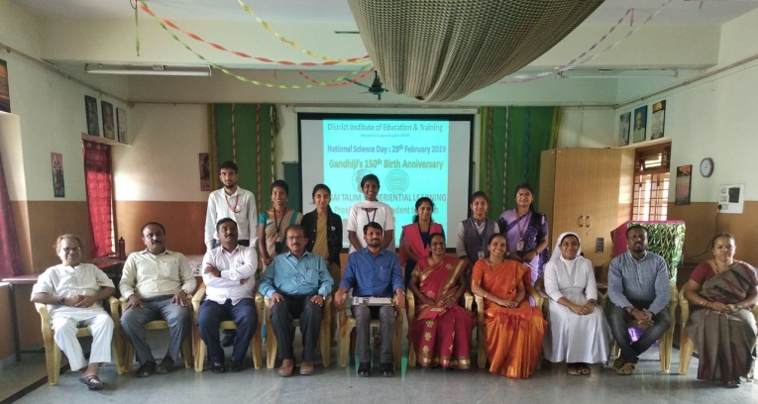
Student teachers from eight different colleges participated with varied types of individual presentations on different topics. The presentations were unique, practical and informative.

The programme ended with the vote of thanks rendered by Mr. Srinivas Gowda, My Institute.

Mr. Jagadeesh, St. Teresa’s Women’s T.T.I. was the M.C. of the progamme.

